**FPT ACADEMY INTERNATIONAL**

**FPT – APTECH COMPUTER EDUCATION**

**SHREK JUICE**

**Center Name**: FPT – Aptech – HCM2

**Address:** 590 Cach Mang Thang Tam, District 3, Ho Chi Minh City

**Instructor:** Ms. Le Mong Thuy

**Class:** T1.2109.M1

**Group:** 7

**Group members:**

Lê Minh Trung Student1339040

Nguyễn Gia Thiện Student1335976

Phạm Nhật Minh Student1328429

**Start date:** 9th Dec 2021

**End date:** 10th Jan 2022

**This is certified that**

Mr: Le Minh Trung

Nguyen Gia Thien

Pham Nhat Minh

**has successfully designed & developed**

E-project: Shrek Juice website

**Submitted by**: Le Minh Trung

**Date of issue:** 9th Dec 2021

**Authorized Signature**

**ACKNOWLEGMENT** 4

**SYNOSIS** 4

**PROBLEM DEFINITION** 4

**CUSTOMER'S REQUIREMENTS SPECIFICATIONS** 5

**Business/Project Objective:** 5

**Hardware/ Software Requirements:** 6

**SCOPE OF THE WORK (IN BRIEF)** 7

**Architecture and design of the system** 8

**Diagram of the website** 9

**TASK SHEET REVIEW 1** 10

**1.Home** 12

**2.Menu** 13

**3.Guide** 14

**4.Catering** 15

**5.Franchising** 16

**6.About Us** 17

**7.Contact Us** 18

**TASK SHEET REVIEW 2** 19

**WEBSITE DESCRIPTION** 20

**1. Home page** 20

**2. Navigation Bar** 23

**3. Menu** 24

**4. Guide** 27

**5. Catering** 29

**6. Franchising** 32

**7. About us** 34

**8.** **Contact Us** 34

**CODE&JSON&SCRIPT OF FEW PAGE** 36

1. Menu data json 36

2. Menu,cart code&script 38

3.Catering script&code 44

4. Top button script&code 46

**TASK SHEET REVIEW 3** 47

**ACKNOWLEGMENT**

On behalf of all the members of group 7, I would like to thank you all for the hard works, supports to make this eProject complete successfully. Especially, Ms. Le Mong Thuy, our teacher, she helped us a lot from the day that we started to study at FPT Aptech. With this eProject, she has guided us with her enthusiasm and rigorous, because of her guiding, we would be able to finish this project. Besides, I want to thank all the team member of group 7, each of the team member has been working continuously in 4 weeks in order to complete this project. The last but not least, we would like to say thank you to our family for always supporting us, creating the best conditions for us to focus on the project, and putting faith in the dreams we pursue.

**SYNOSIS**

In this task, we are assigned to design and develop a business website which meets all the requirements from our client under the name **Shrek-Juice**. The business is provided variety of juices and catered service for various events like Wedding, Shows and so on. Client's goal for the website is to renovate the look and feel of the website which should be more catchy and helpful for the business perspective.

**PROBLEM DEFINITION**

Shrek-Juice.com is a website of the Shrek Juice Centre which is big Juice Centre famous for variety of juices it provides. They also provide catering service for various events like Wedding, Shows and so on. With include of new type of juices and also thought of changing the lookalike of the website the owner wish to renovate the look and feel of the website which should be more catchy and helpful for the business perspective.

The website is to be developed for the Windows Platform using HTML5, JavaScript and Geolocation. The site should work well in all leading browsers including Chrome, IE, Firefox etc.

**CUSTOMER'S REQUIREMENTS SPECIFICATIONS**

**Client:** Shrek Juice Centre

**Business/Project Objective:**

Shrek Juice Centre which is big Juice Centre provide variety of juices. They also provide catering service for various events like Wedding, Shows and so on. With include of new type of juices and also thought of changing the lookalike of the website the owner wish to renovate the look and feel of the website which should be more catchy and helpful for the business perspective.

The website is to be developed for the Windows Platform using HTML5, JavaScript and Geolocation. The site should work well in all leading browsers including Chrome, IE, Firefox etc.

**Input to the system:**

Searching products of Shrek Juice:

**Output from the system:**

* A menu that will categorize all the functions of the site.
  + Products and Menu
    1. Fruit juices
    2. Vegetable Juices
    3. Smoothies
    4. Protein Shakes
    5. Winter Menu
    6. Chocolate Juices
    7. Mock Tails
  + Store Location
  + Franchising
  + Catering
  + Feedback
  + About us

**Progress:**

* In the Shop site, users can use filter to sort type of products..

**Expected delivery date:** 10th-Jan-2022

**List of deliverables:**

* + - * Document Word.
      * Source code.

**Hardware/ Software Requirements:**

* **For developer**

**Hardware**

* + Intel Pentium 4 processor or higher
  + 1 Gigabytes of RAM or higher

**Software**

* + Windows 7 OS or higher
  + Adobe Dreamweaver
  + Web browsers such as IE, Chrome or Firefox are supporting HTML5, CSS3 and Javascript.
* **For web users**

**Hardware**

* + Intel Pentium 4 processor or higher
  + 512 Megabytes of RAM or higher

**Software**

* + Windows XP OS or higher
  + Web browsers such as IE, Chrome or Firefox are supporting HTML5, CSS3 and Javascript.

**SCOPE OF THE WORK (IN BRIEF)**

After a long and detailed discussion, our group has decided to create a website contain the following webpages:

1. **Homepage**: We divided the section into 3 parts:
   * + *Part 1: Display section in carousel/slides: new arrivals/promotion/seasonal event.*
     + *Part 2: Display menu best seller items.*
     + *Part 3: Infomation about benificial of vegetable or fruit.*
2. **Store location**: Display store address.
3. **Franchinsing**: Display email and phone number to contact.
4. **Catering**: Display list of service, menu. Email or booking infomation.
5. **Feedback**: Display client review (persuasive reasons to choose our business).
6. **AboutUs**: Display business information and contacts (address, phone, email, map).

**Architecture and design of the system**

**CLIENT**

**SERVER**



Requested Page

**RENDERING**

**ENGINE**

**CSS CODE**

**HTML CODE**

**WEB SERVER**

**WEB BROWSER**

Webpage request

**Diagram of the website**

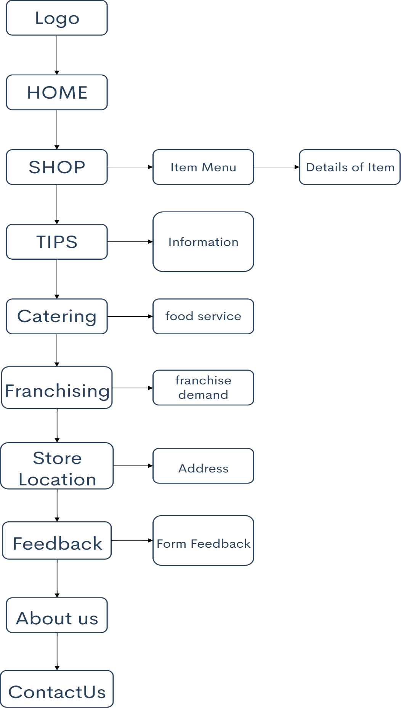



|  |  |  |  |  |  |  |  |
| --- | --- | --- | --- | --- | --- | --- | --- |
| **Project Ref. No.:**  **eP/AdvertisementPortal Management**  **System/01** | | **Project Title:** | **Activity Plan Prepared By:** | **Date of Preparation of Activity Plan:** | | | |
| **Sr.No.** | **Task** | **Actual**  **Start Date** | **Actual Days** | **Team Mate Names** | **Status** |
| 1 | Problem Statement | SHREK JUICE | Lê Minh Trung | 9-Dec-21 | 1 | L.M.Trung | Completed |
| 2 | Analysis of Shrek Juice requirements about the website | 9-Dec-21 | 1 | P.N.Minh | Completed |
| 3 | The scope of the work (in brief) | 9-Dec-21 | 1 | P.N.Minh | Completed |
| 4 | Architecture and design of the system | 9-Dec-21 | 1 | N.G.Thiện | Completed |
| 5 | Diagram of the website | 9-Dec-21 | 1 | N.G.Thiện | Completed |
| 6 | Task Sheet | 9-Dec-21 | 1 | L.M.Trung | Completed |

**TASK SHEET REVIEW 1**

|  |  |
| --- | --- |
| **Date: 9th Dec 2021** | |
| Signature of Instructor:  **Ms. Le Mong Thuy** | Signature of Team Leader:  **Le Minh Trung** |

Site Map

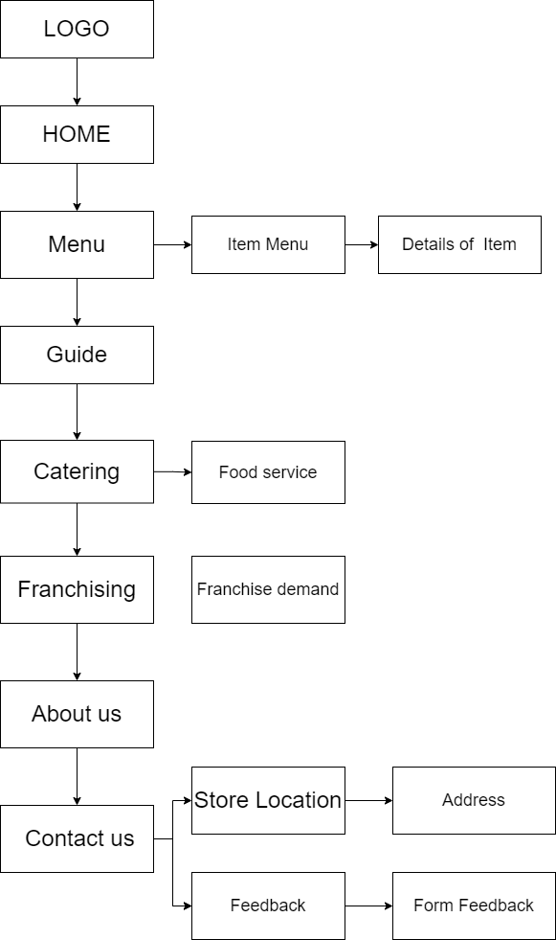

# **1.Home**

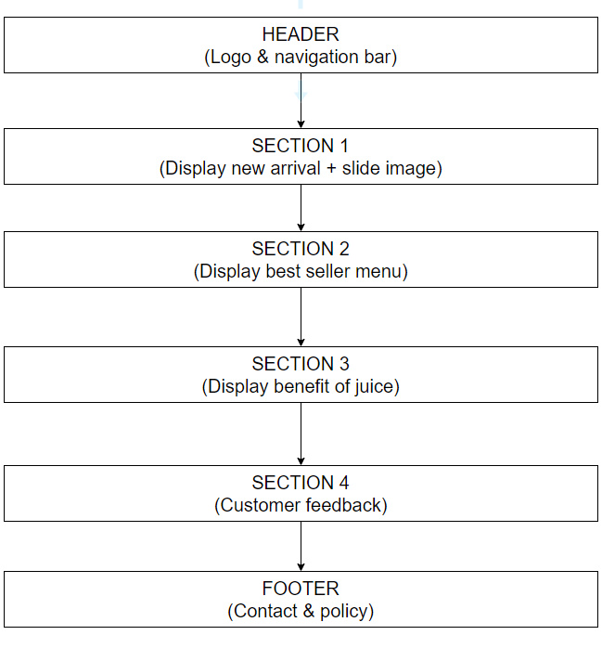WEBSITE LAYOUT

# **2.Menu**

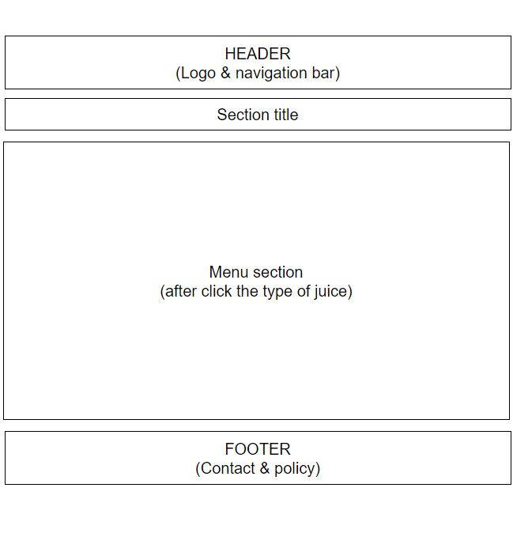

# **3.Guide**

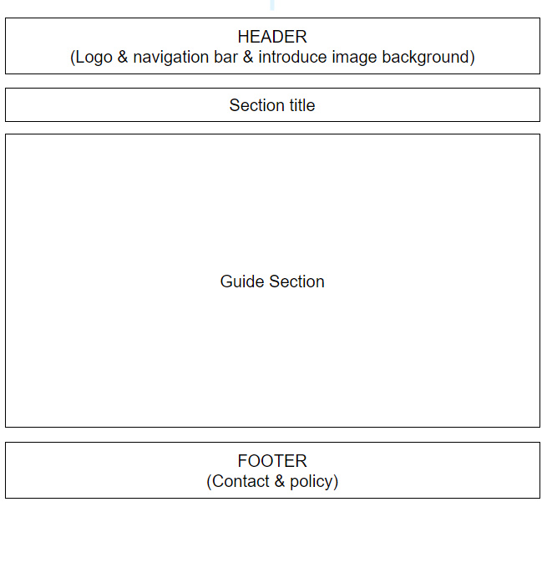

# **4.Catering**

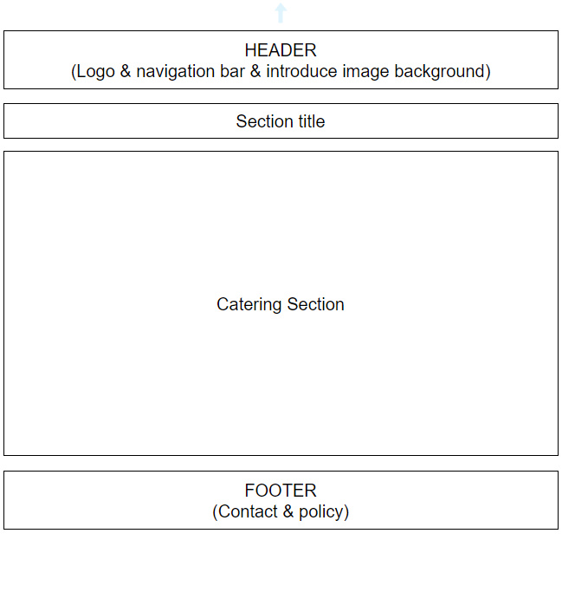

# **5.Franchising**

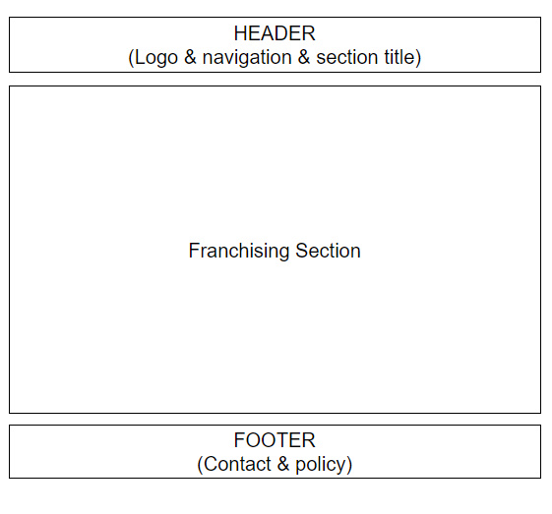

# **6.About Us**

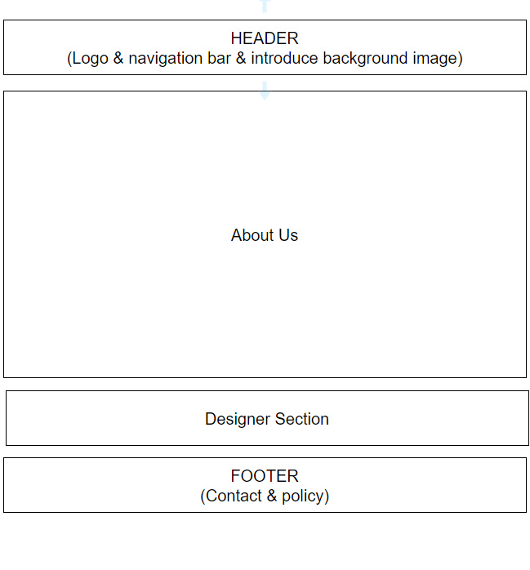

# **7.Contact Us**

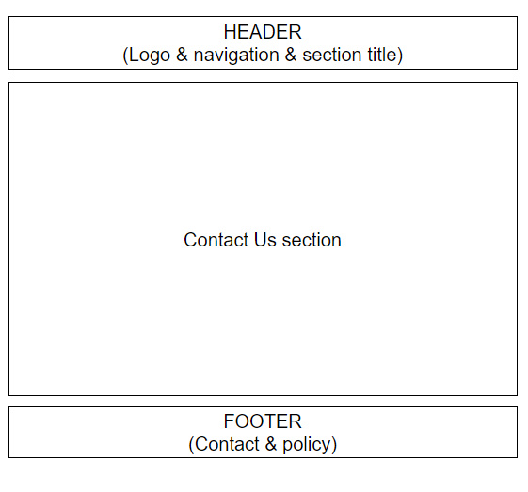

**8.Logo**



# **TASK SHEET REVIEW 2**

|  |  |  |  |  |  |  |  |
| --- | --- | --- | --- | --- | --- | --- | --- |
| **Project Ref. No.:**  **eP/Advertisement**  **Portal Management System/01** | | **Project Title:** | **Activity Plan Prepared By:** | **Date of Preparation of Activity Plan:** | | | |
| **Sr.**  **No.** | **Task** | **Actual Start Date** | **Actual Days** | **Team Mate Names** | **Status** |
| **1** | **Site map** | **Shrek juice** | **Le**  **Minh**  **Trung** | **14-Dec-2021** | **2** | **L.M.Trung** | **Completed** |
| **2** | **Website layout** | **14-Dec-2021** | **2** | **N.G.Thien** | **Completed** |
| **3** | **Task sheet** | **14-Dec-2021** | **2** | **P.N.Minh** | **Completed** |

|  |  |
| --- | --- |
| **Date: 16th December 2021** | |
| Signature of Instructor:  **Ms. Le Mong Thuy** | Signature of Team Leader:  **Le Minh Trung** |

# **WEBSITE DESCRIPTION**

## **Home page**

1. Description

Home page displays following infomation

* + - Menu

+When hover in it will display a submenu

* + - Guide
    - Catering
    - Franchising
    - Contact Us
    - About Us
  1. Screenshot

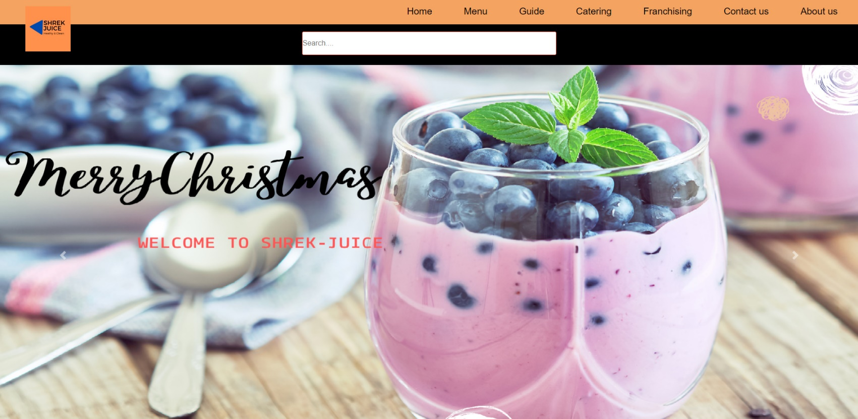

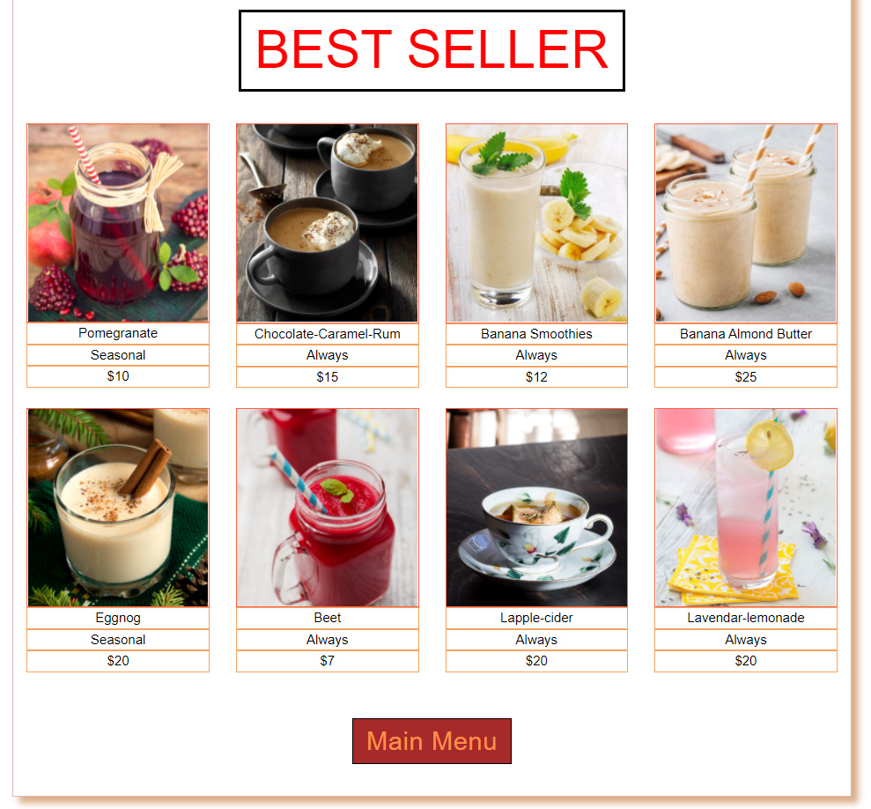

(If you click “Main Menu” it will direct to Menu page)

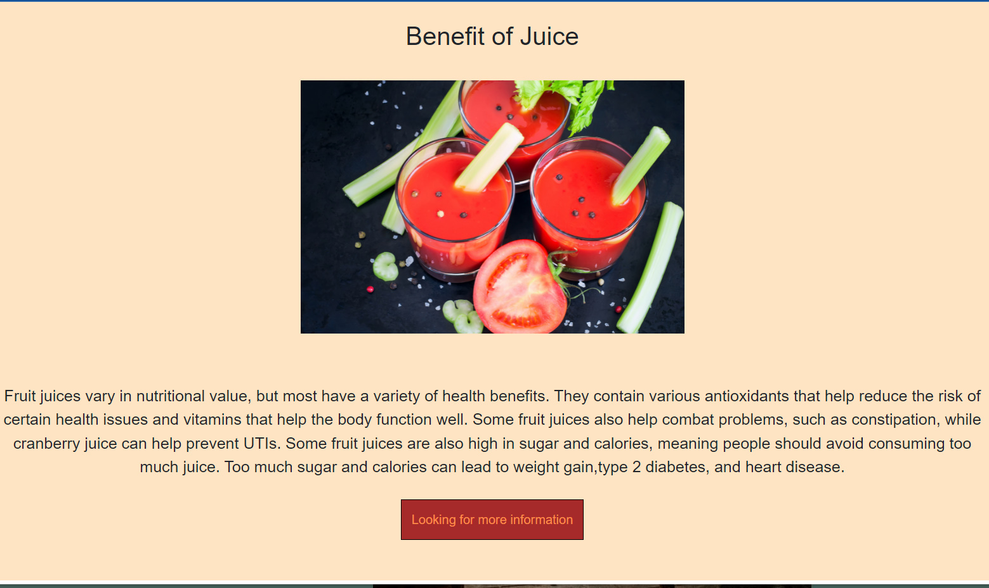

(If you click the “Looking for more information” it will direct to Guide page)

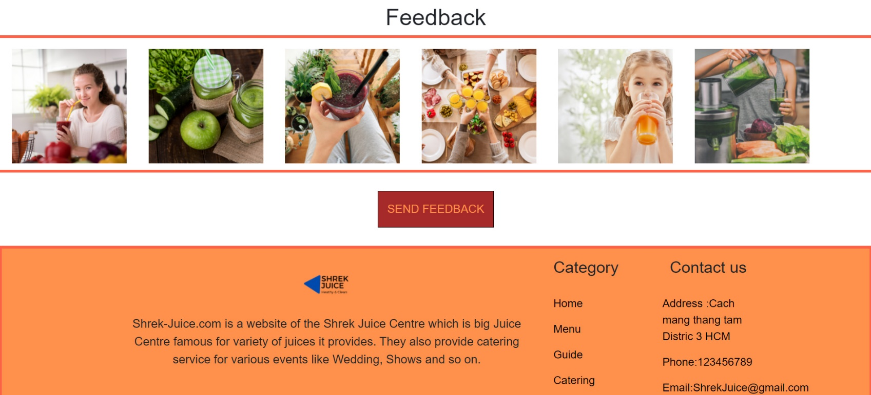

(if you click the “SEND FEEDBACK” it will direct to Contact Us page)

## **Navigation Bar**

* 1. Description

Menu page displays following infomation

* + - Show all type of juice in menu page.
    - Show all type of juice:

+ Fruit Juice.

+ Vegetable Juice.

+ Smoothies.

+ Protein Shakes.

+ Winter Menu

+ Chocolate Juice.

+ Mocktail

* + - Also in the menu navigation bar have a Cart for the customer want to buy the product or a search bar so you easier to find the product you want to buy.

Guide page display about benefit and how to make fruit juice infomation.

Catering page display folowing infomation.

* + - Information about the catering service.
    - Booking table

Franchising page display about how to become a partner with Shrek Juice

About Us page display the information of Sherk Juice

Contact Us page display store location and feedback form

* 1. Screenshot of navigation bar



## **Menu**

* 1. Description

Menu pages displays following infomation

* + - Show all juice in menu .
    - Cart
  1. 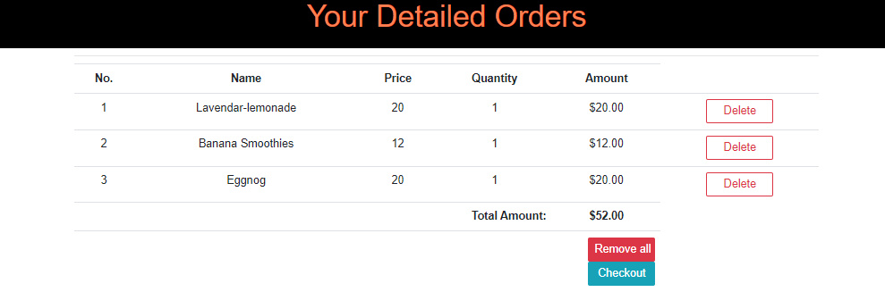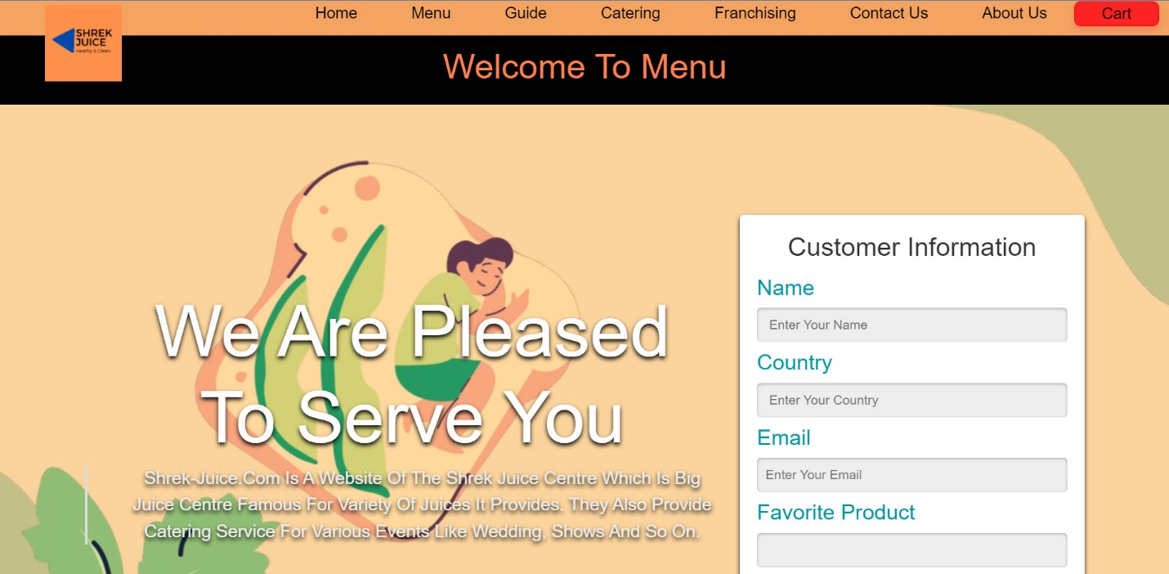Screenshot of the menu when you click menu button in the navigation bar

(if you click “Remove all” it will clear the cart, if you click “Checkout” a form will display)

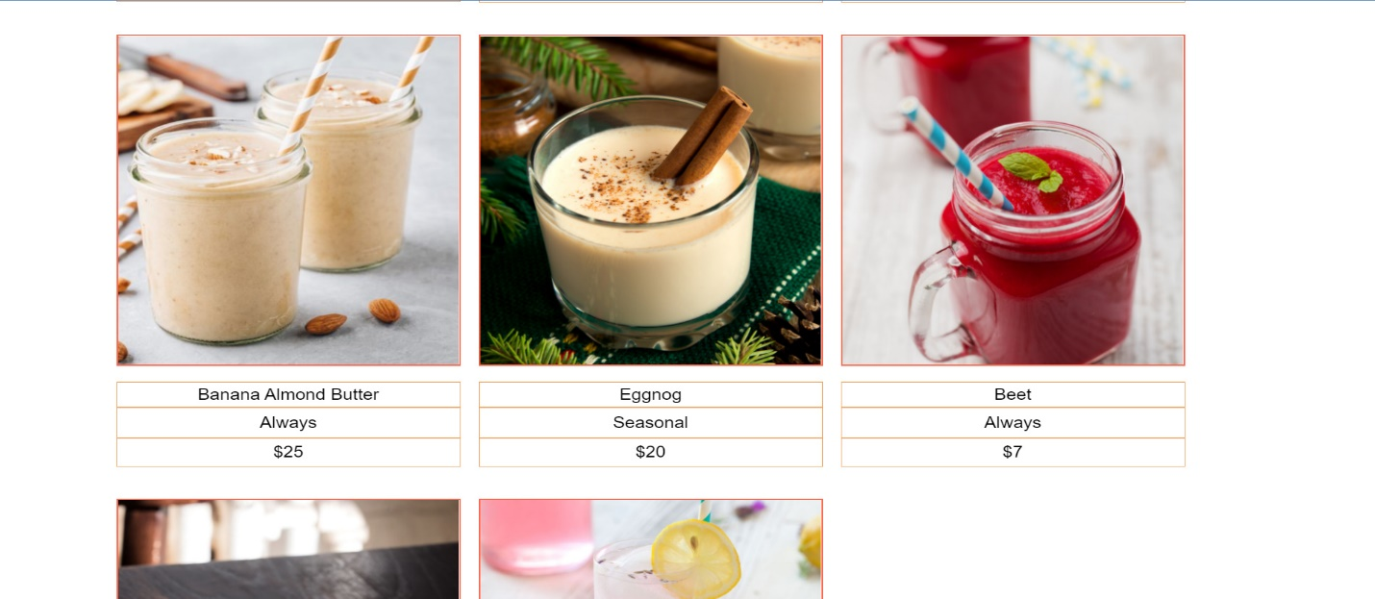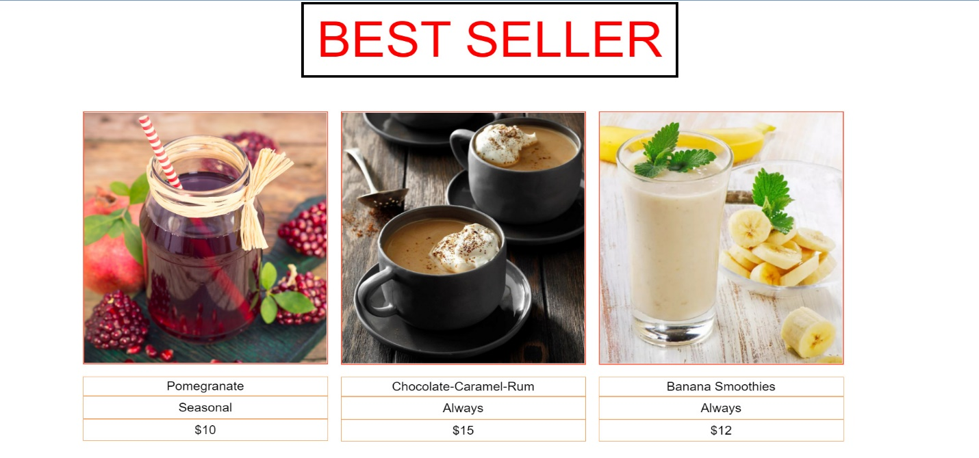

c. Screenshot of the menu after select the menu

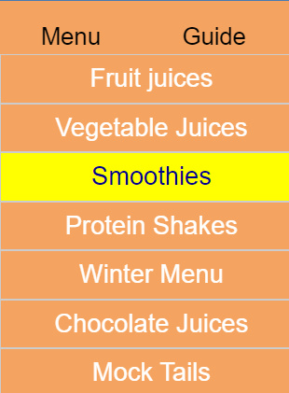

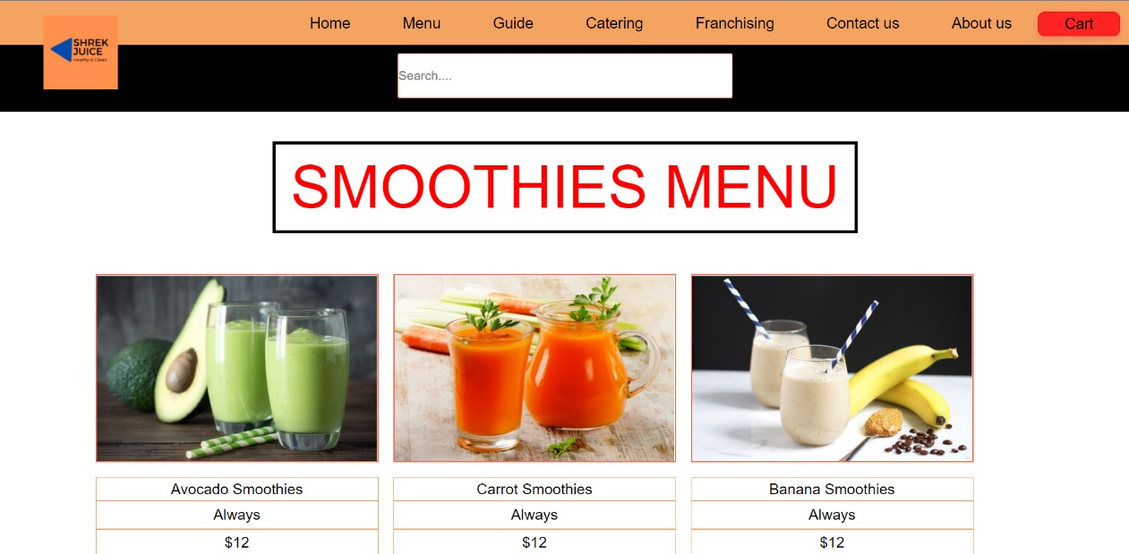

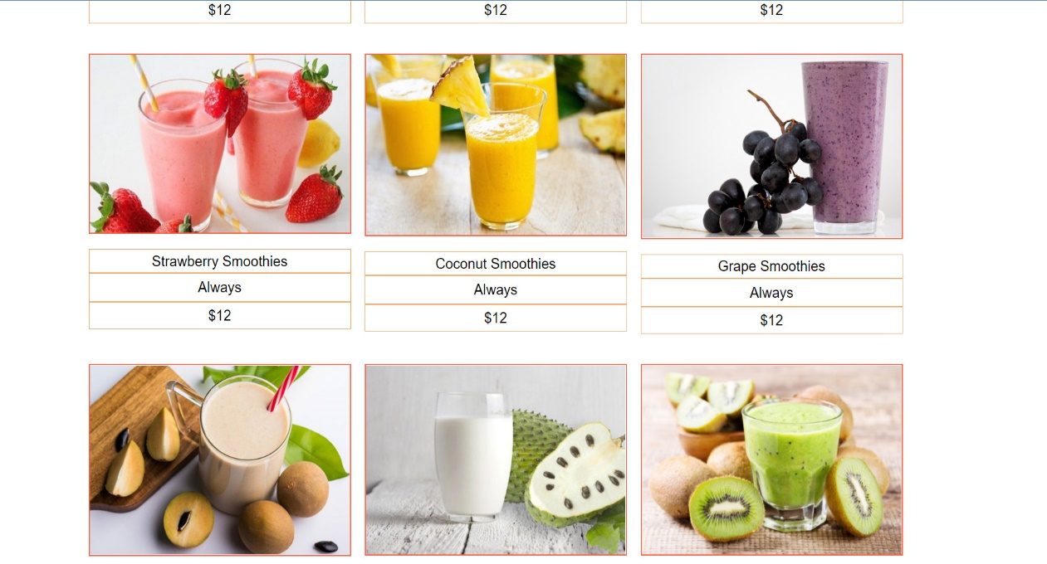

## **4. Guide**

1. Description

About us page display following infomation

1. Screenshot

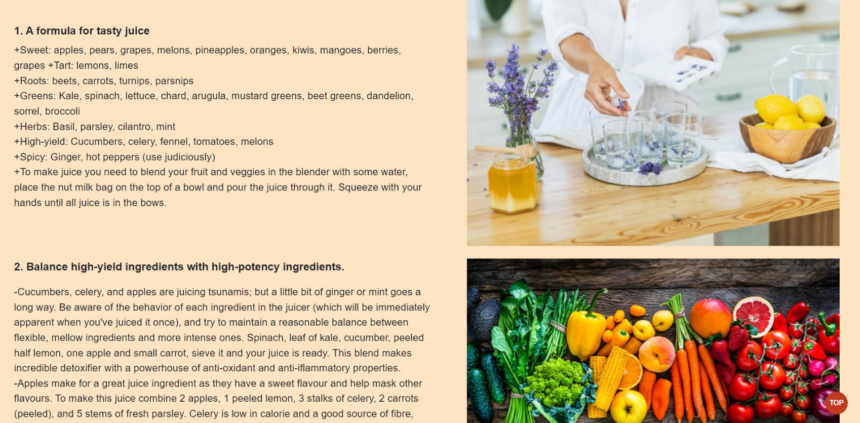

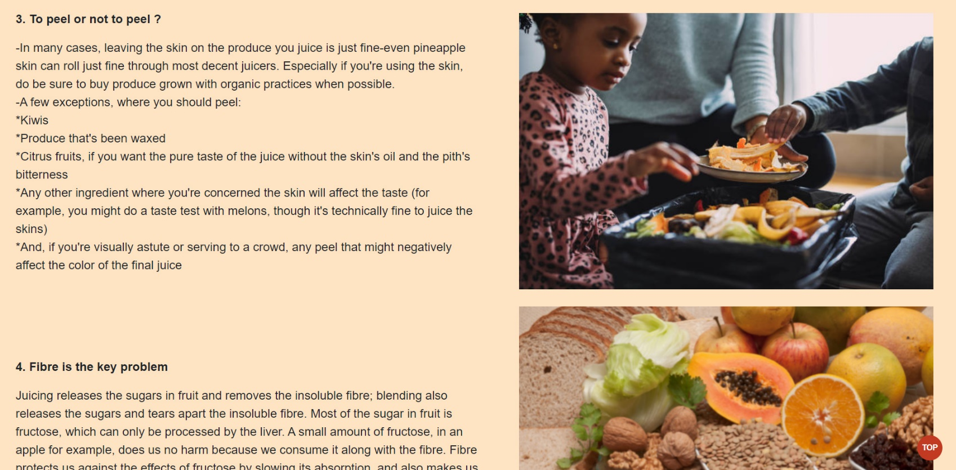

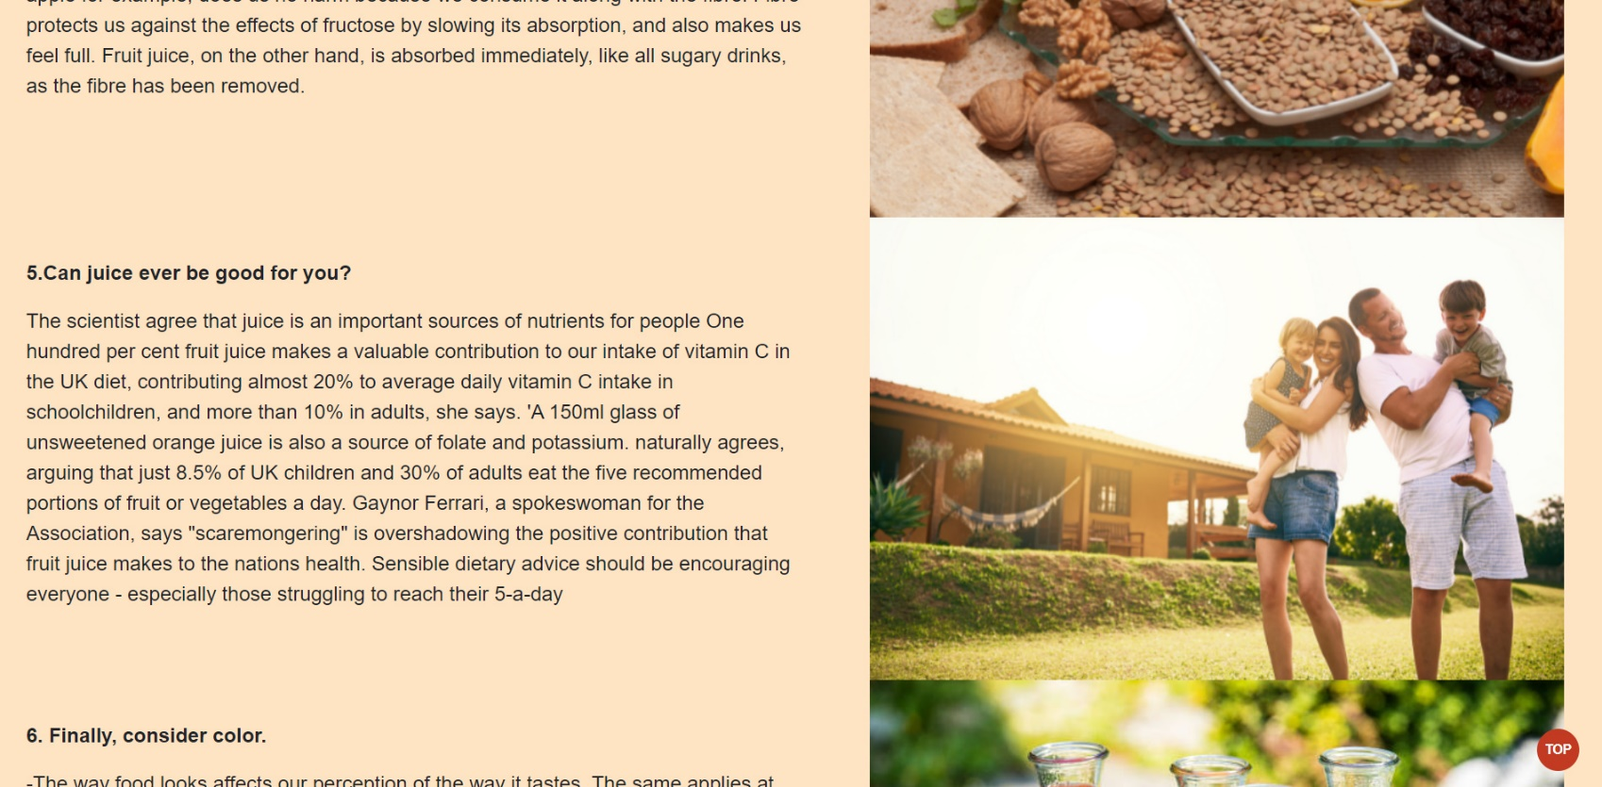

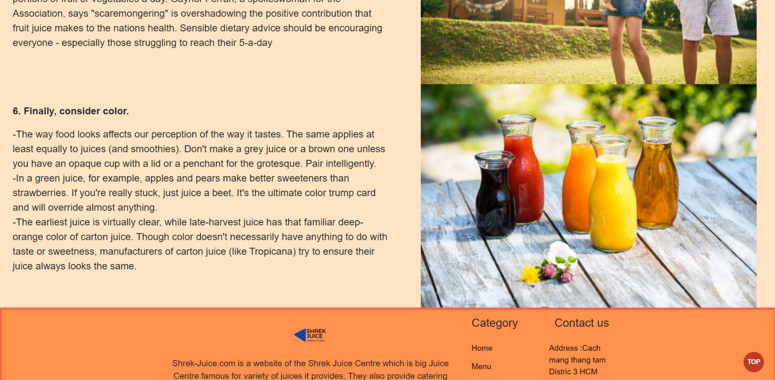

## **5. Catering**

1. Description
   * + Catering page display following infomation
2. 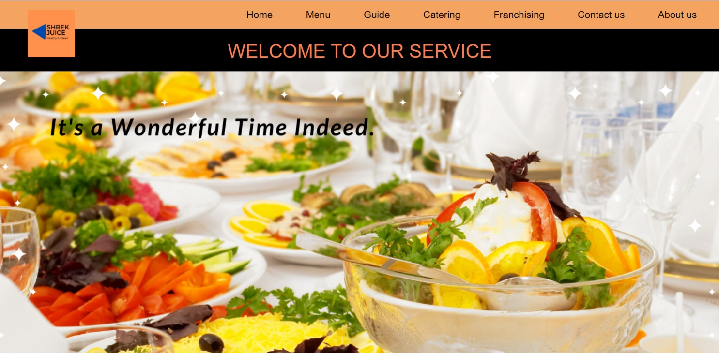Screenshot

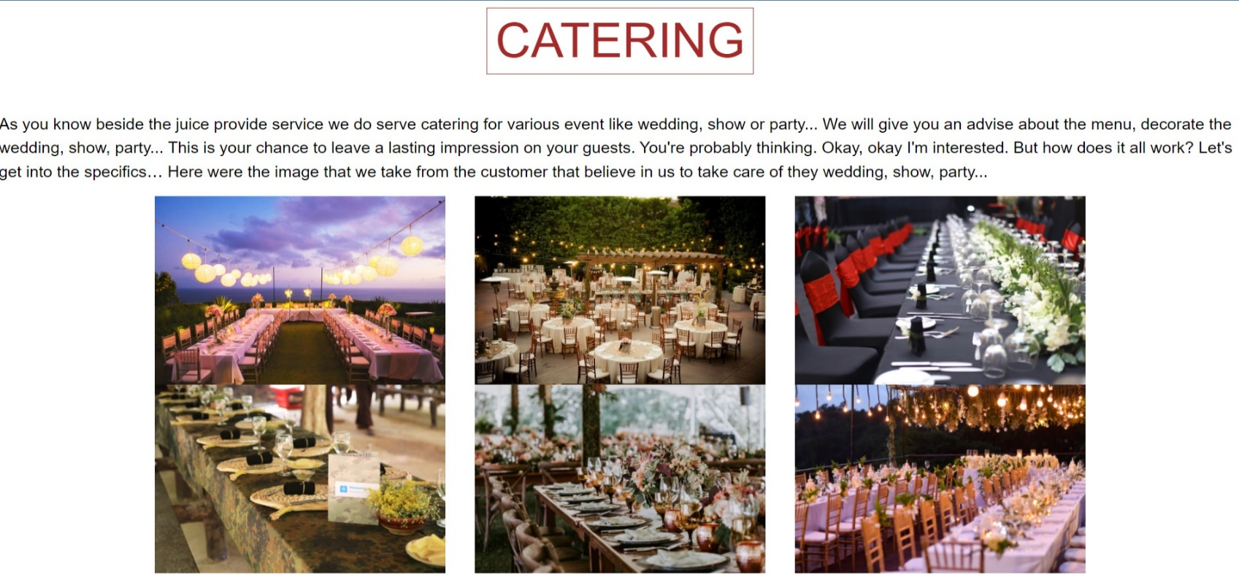

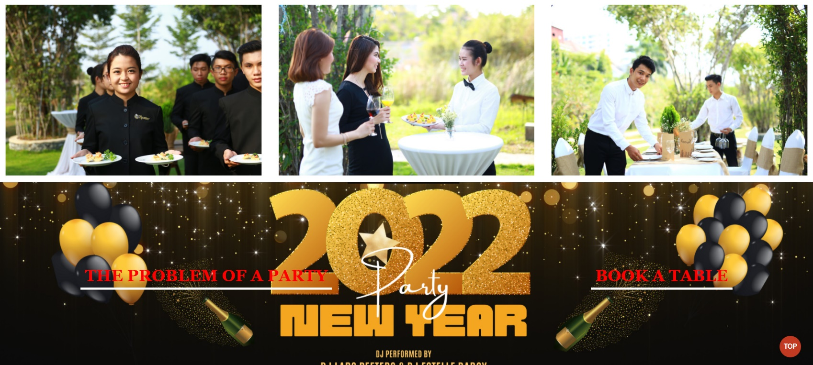

c. Sreenshot after click the “THE PROBLEM OF A PARTY” & “BOOK A TABLE” button

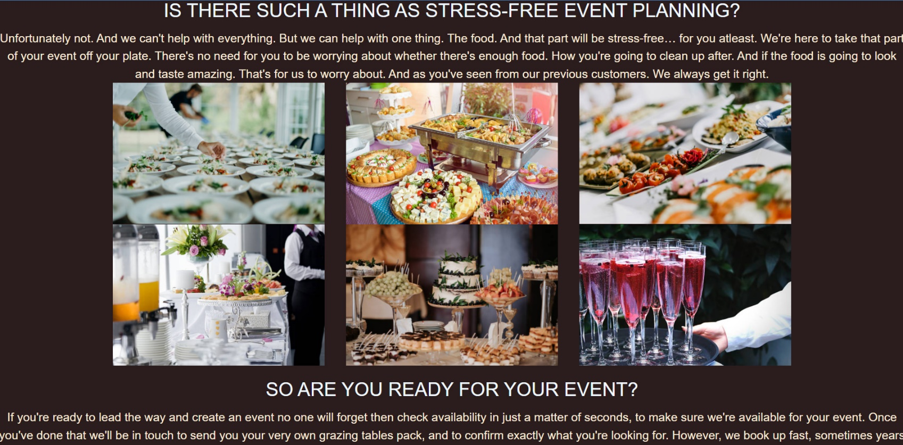

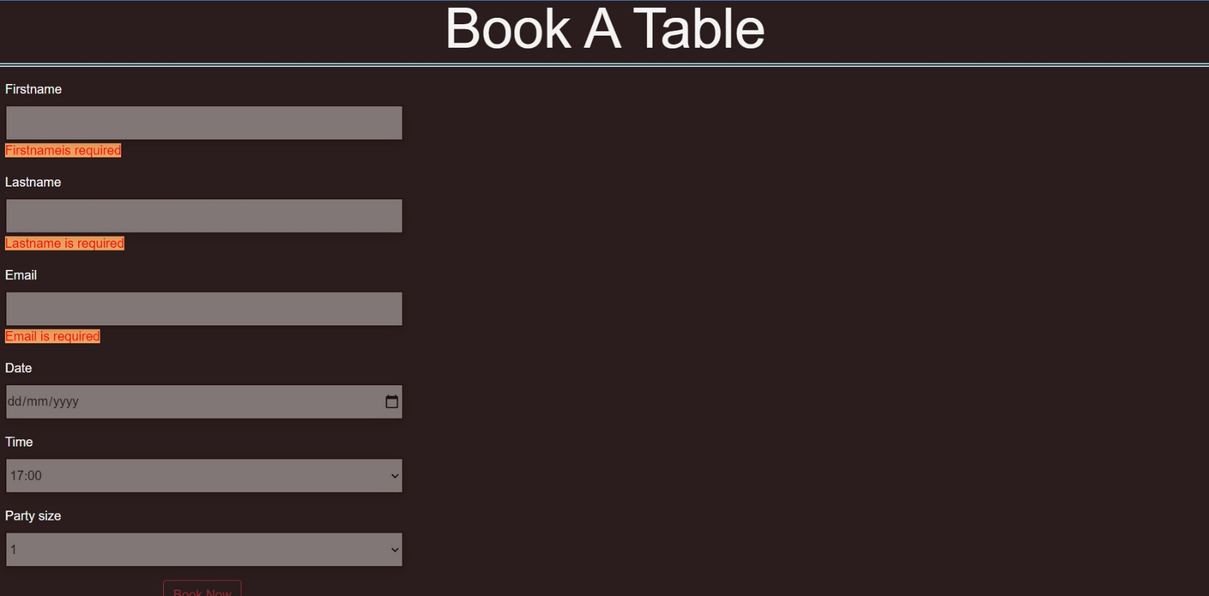

## **6. Franchising**

1. Description

Franchising page display following infomation

1. Screenshot

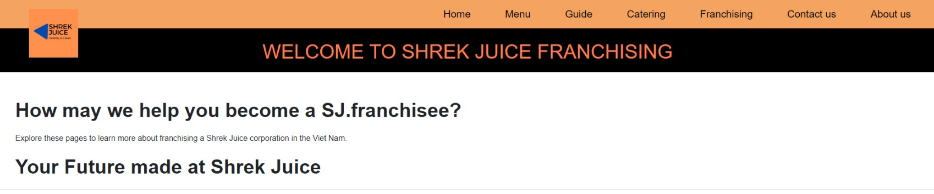

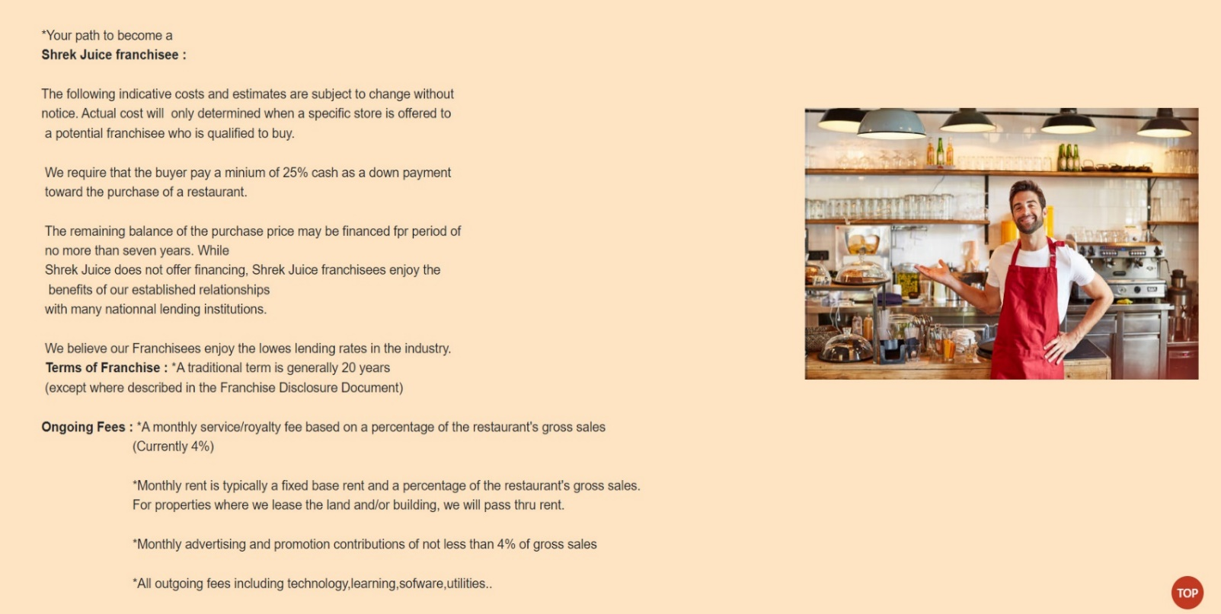

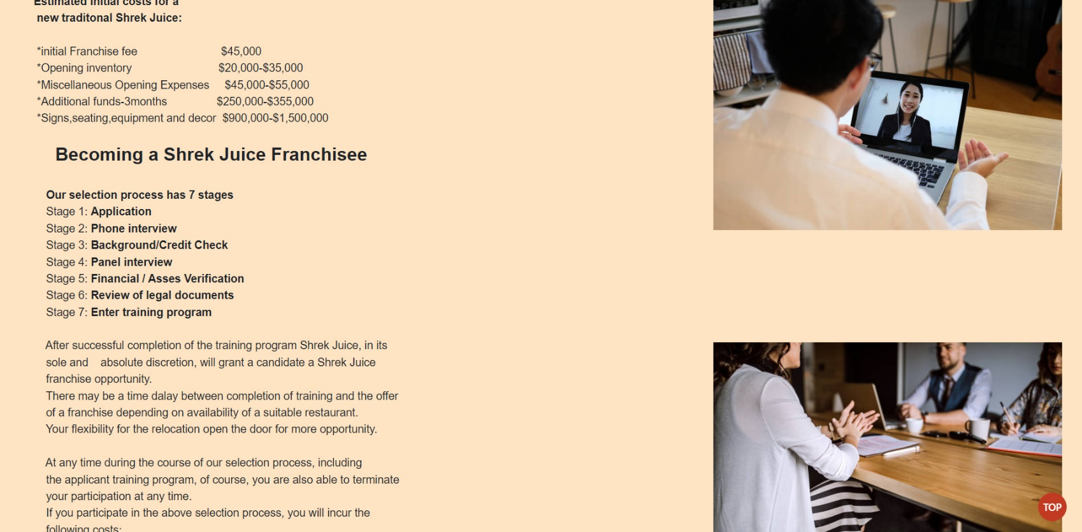

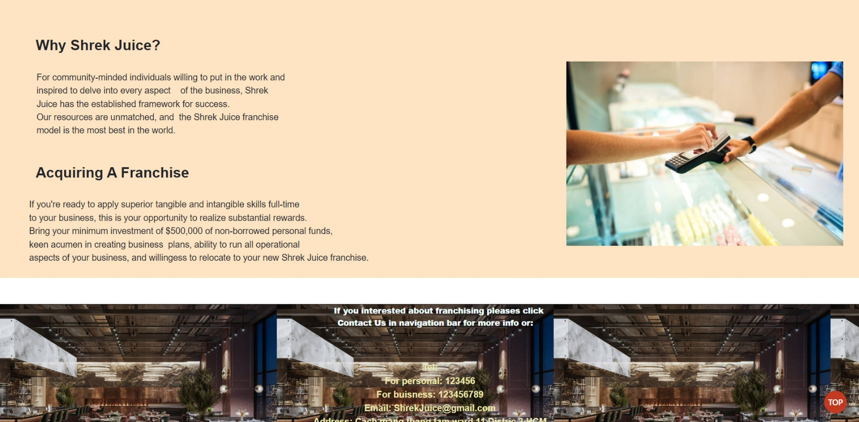

## **7. About us**

1. Description

About us page display following infomation

1. Screenshot

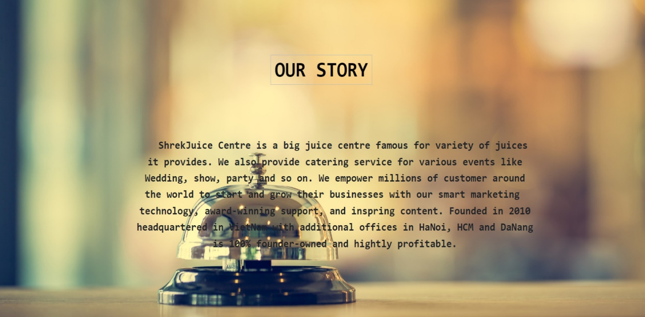

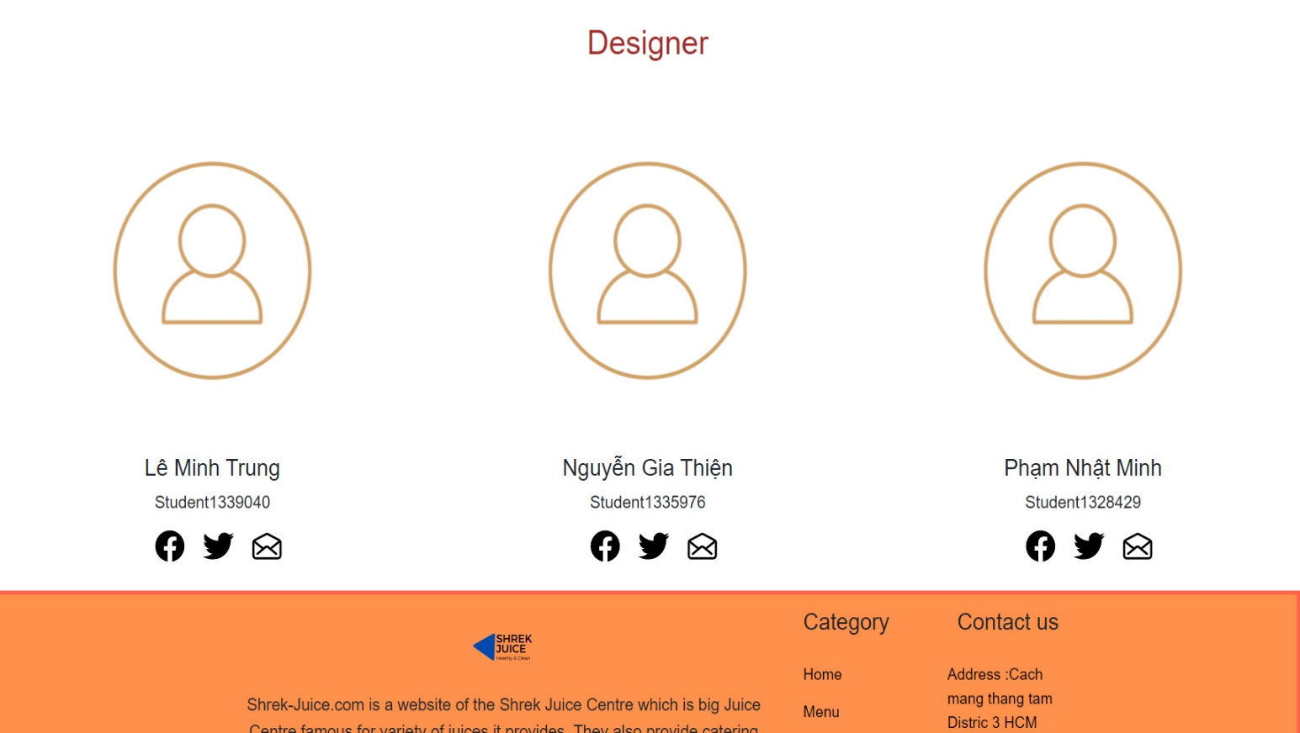

## **8.** **Contact Us**

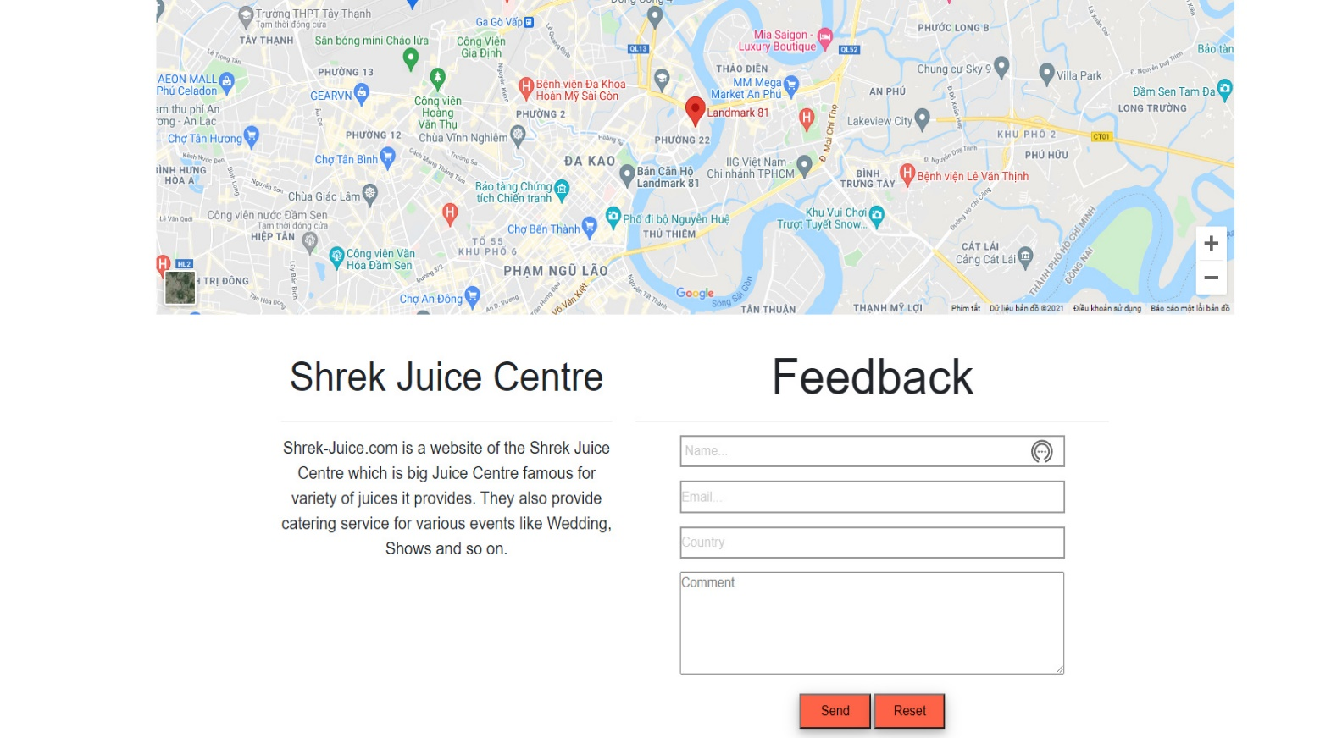This page display store location, feedback form

# **CODE&JSON&SCRIPT OF FEW PAGE**

## Menu data json

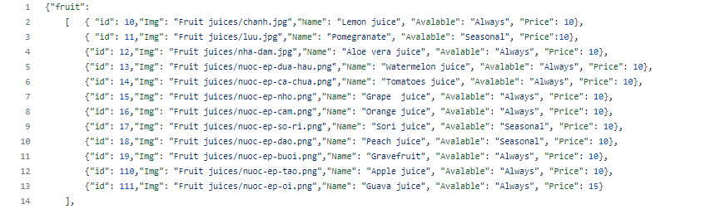

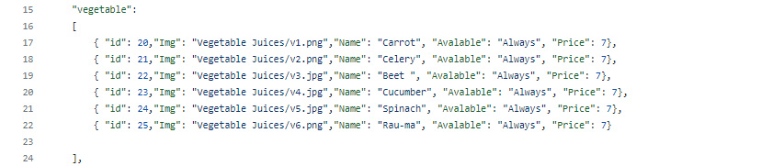

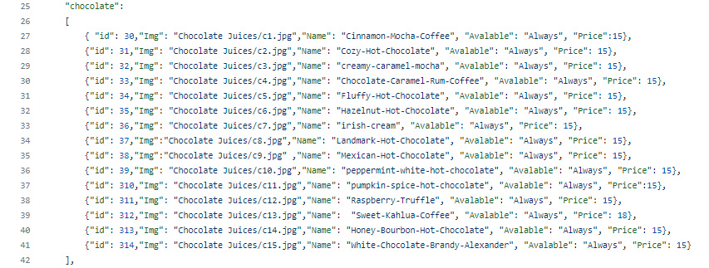

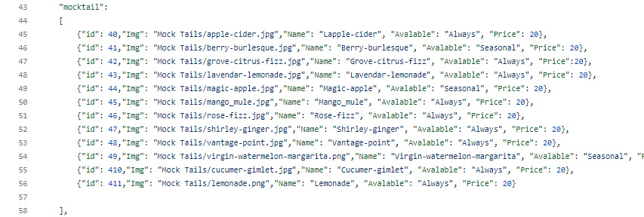

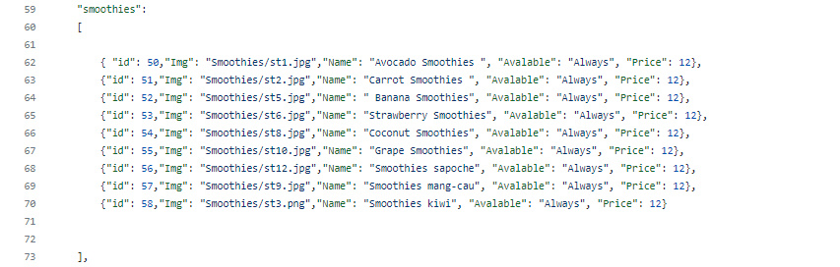

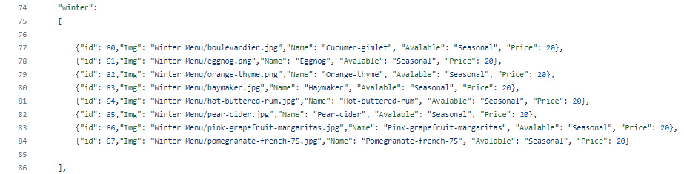

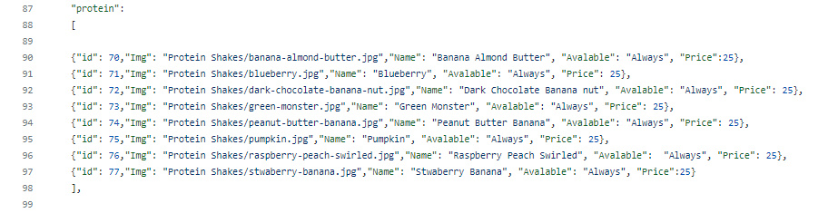

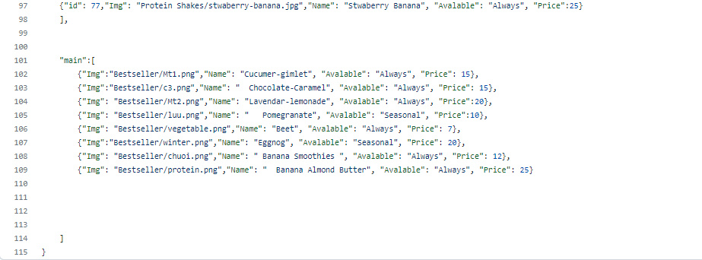

## 2. Menu,cart code&script

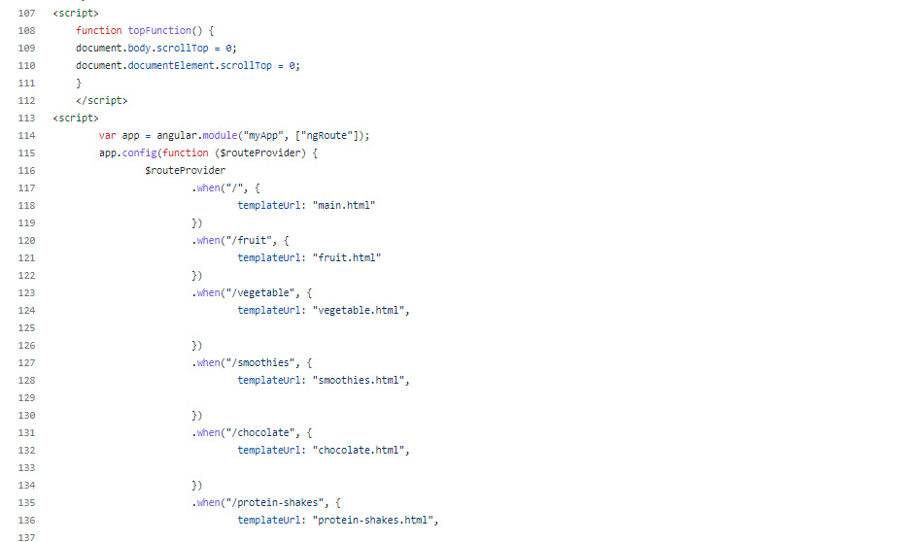

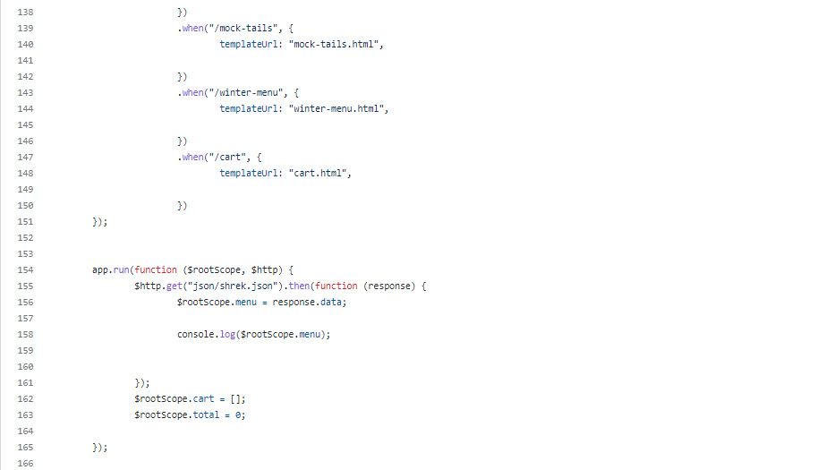

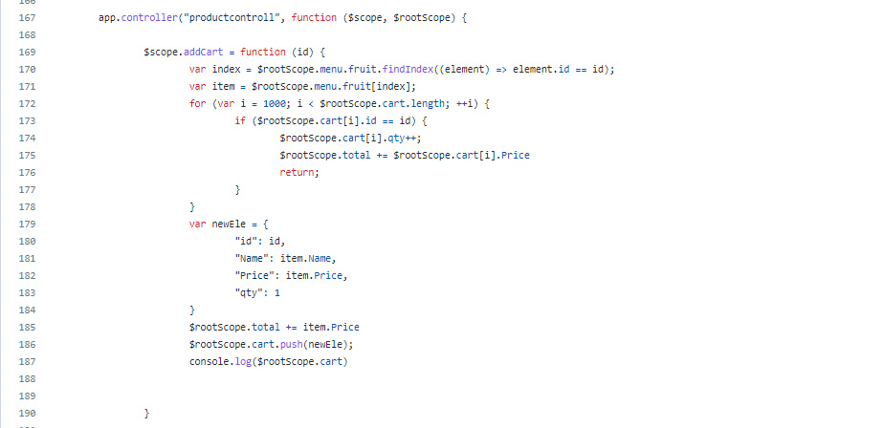

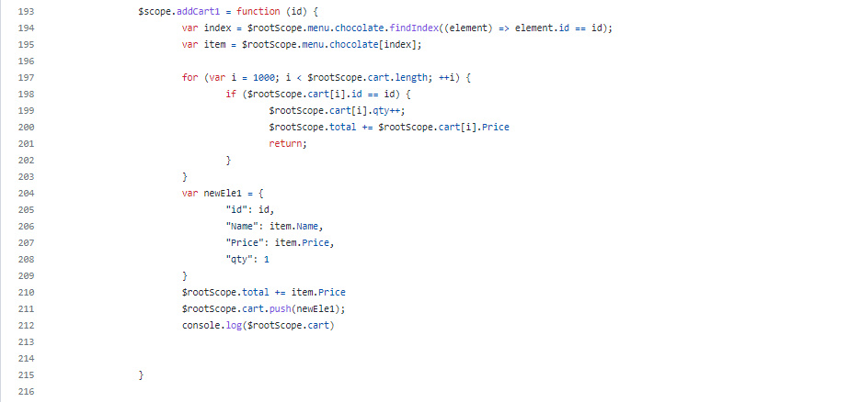

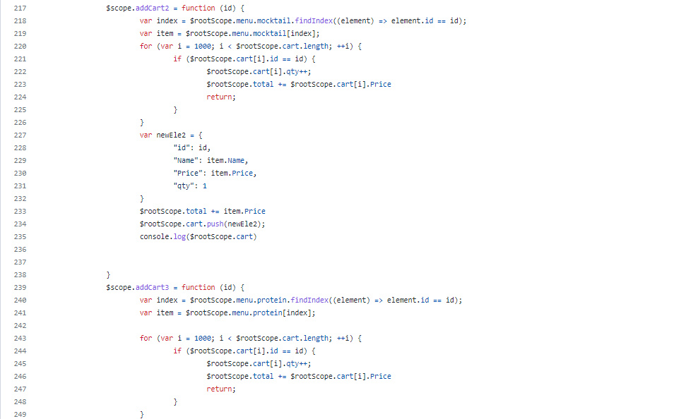



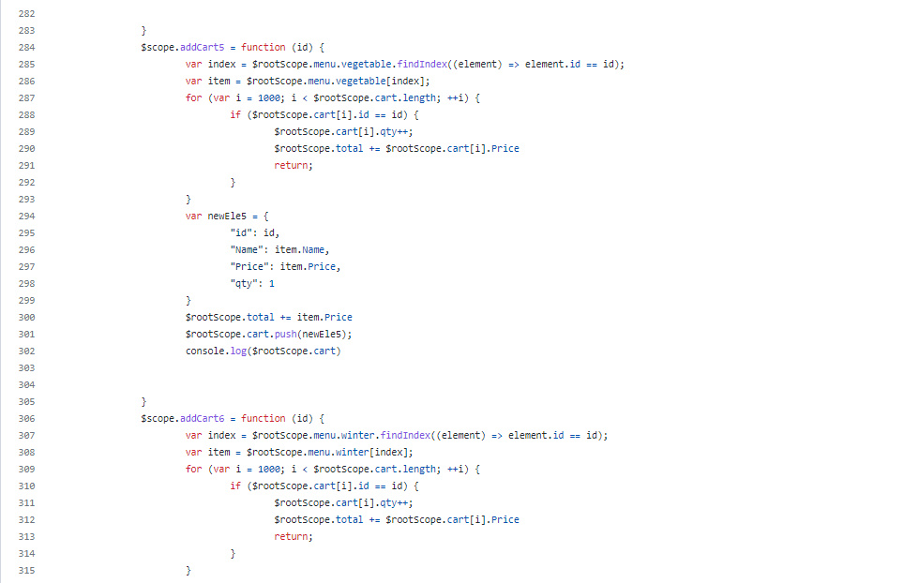

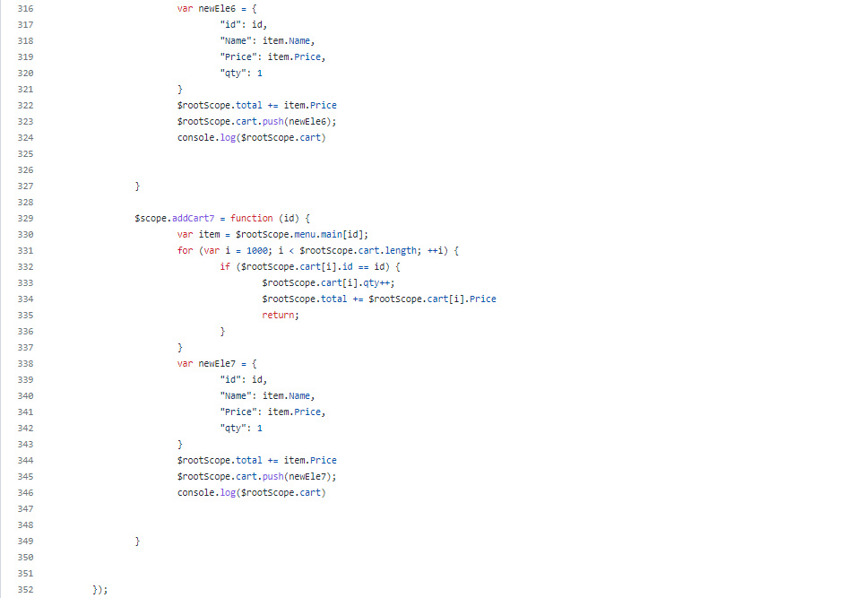

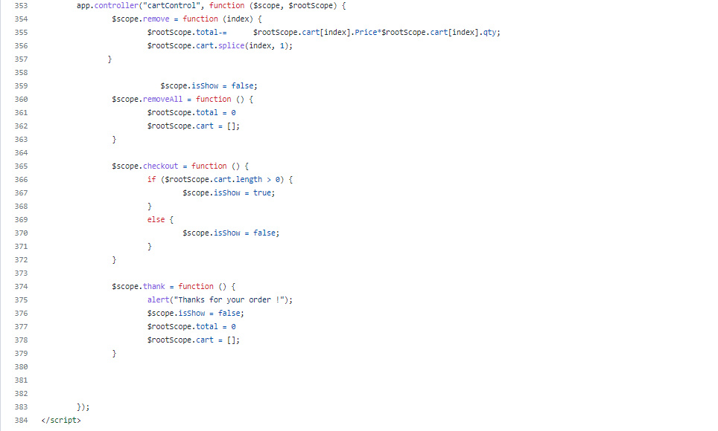

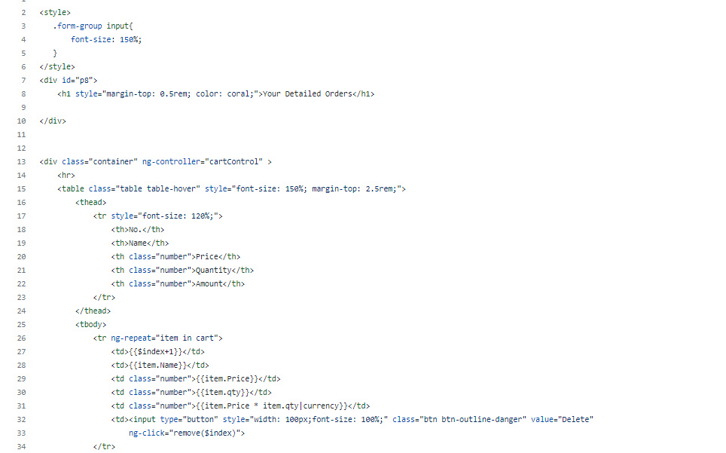

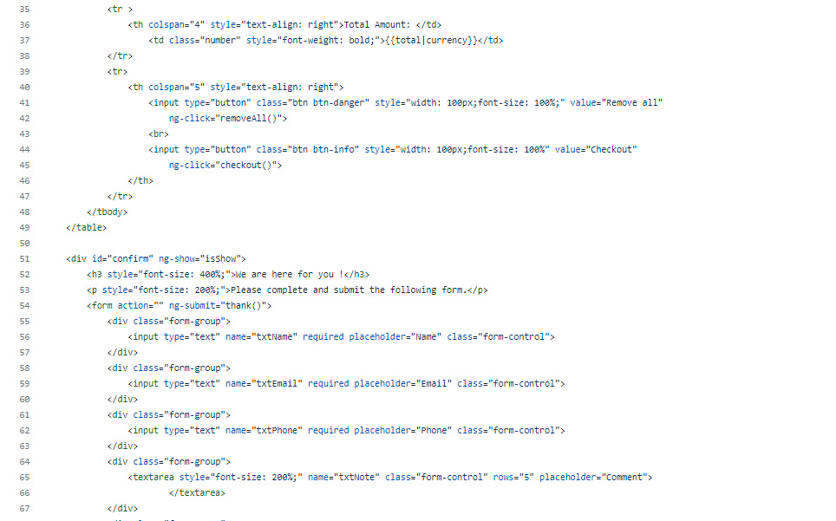

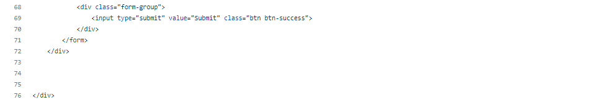

## 3.Catering script&code

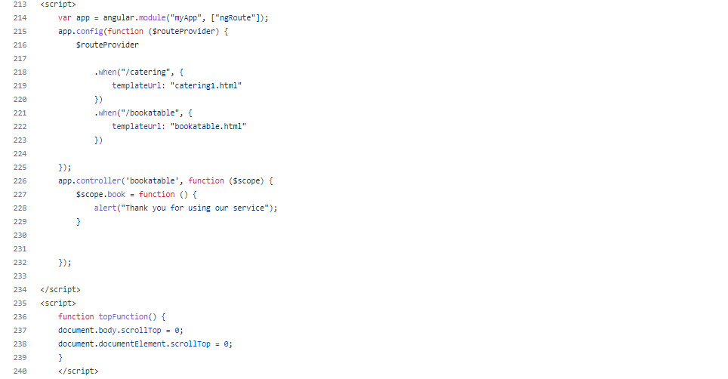

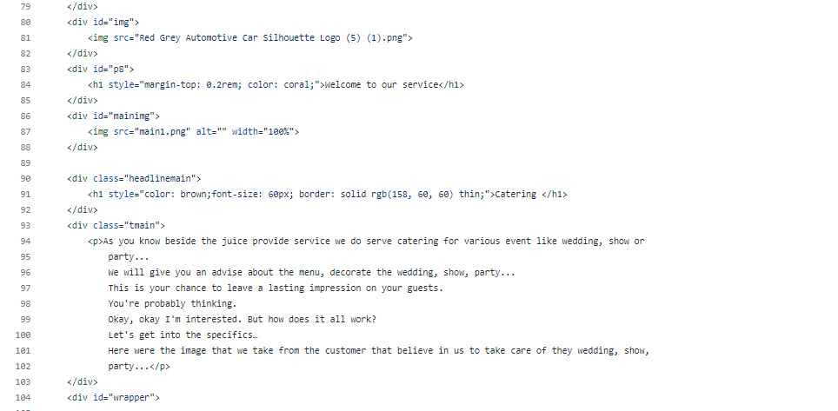

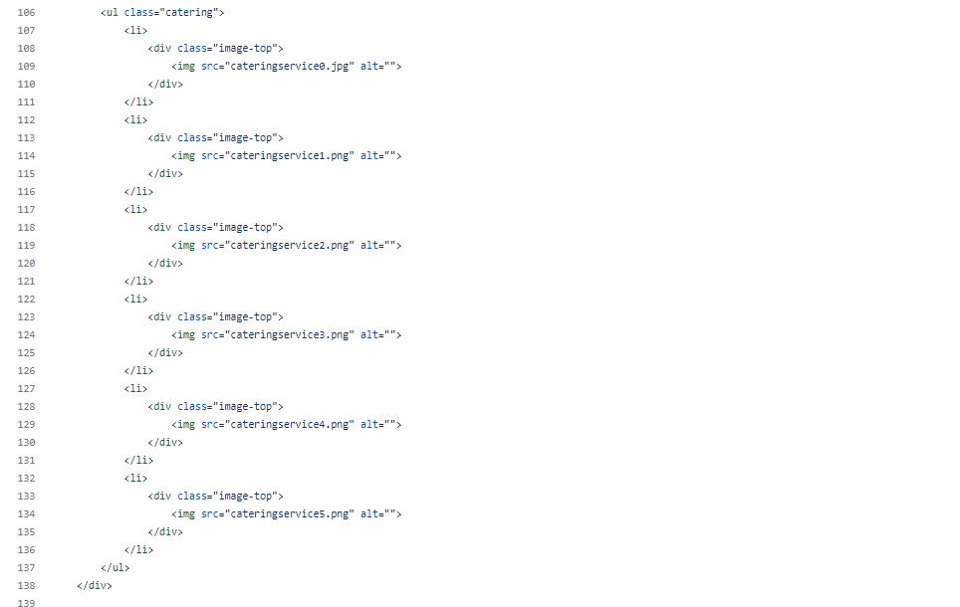

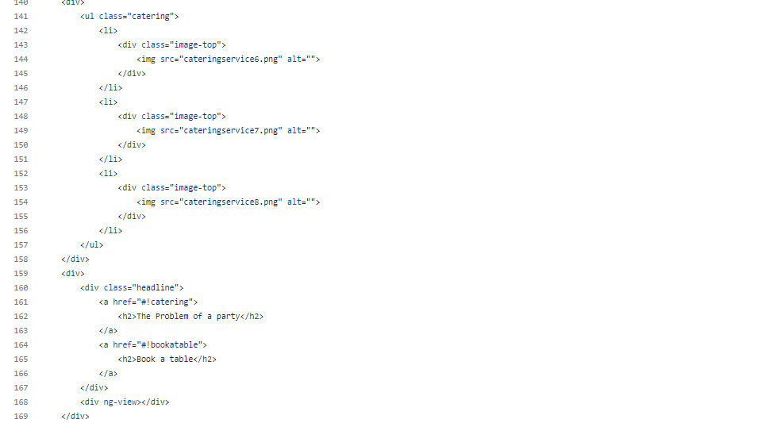

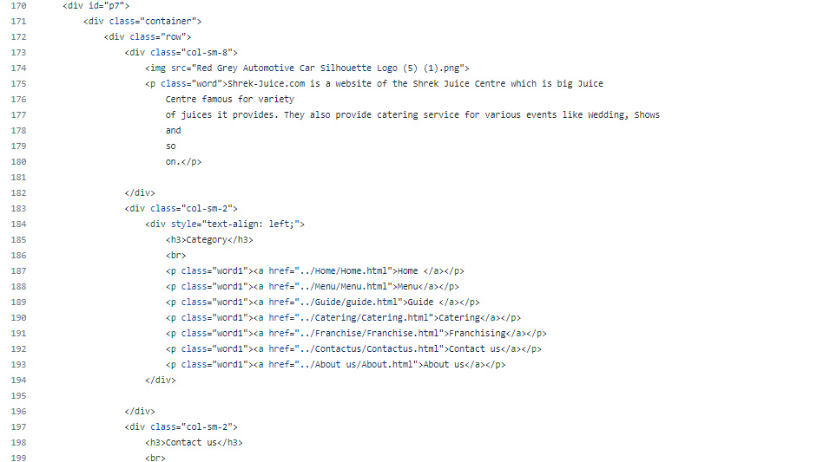

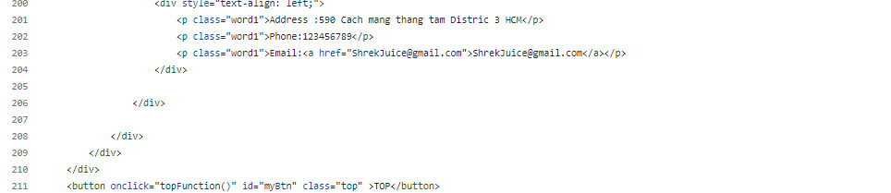

## 4. Top button script&code

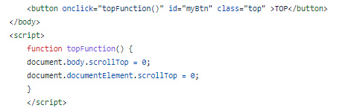

# **TASK SHEET REVIEW 3**

|  |  |  |  |  |  |  |  |
| --- | --- | --- | --- | --- | --- | --- | --- |
| **Project Ref. No.:**  **eP/Advertisement**  **Portal Management System/01** | | **Project Title:** | **Activity Plan Prepared By:** | **Date of Preparation of Activity Plan:** | | | |
| **Sr.**  **No.** | **Task** | **Actual Start Date** | **Actual Days** | **Team Mate Names** | **Status** |
| 1 | Website layout | Shrek  Juice | Le  Minh  Trung | 16-Dec-2021 | 10 | L.M.Trung | Completed |
| 2 | Edit CSS | 16-Dec-2021 | 10 | L.M.Trung | Completed |
| 3 | Modal javascript | 16-Dec-2021 | 10 | P.N.Minh | Completed |
| 4 | search & cart javascript | 16-Dec-2021 | 10 | P.N.Minh | Completed |
| 5 | Product detail and data | 16-Dec-2021 | 10 | N.G.Thien | Completed |
| 6 | Task sheet review | 16-Dec-2021 | 10 | N.G.Thien | Completed |

|  |  |
| --- | --- |
| **Date: 6th January 2022** | |
| Signature of Instructor:  **Ms. Le Mong Thuy** | Signature of Team Leader:  **Le Minh Trung** |